Beskriv kort vilka lärdomar du kommer att ta med dig från de andra projekter till slutprojekt . Vad kommer du att göra annorlunda för att få slutprojekt att flyta bättre än de andra projekter?
För det första var det mest feedback jag fick från läraren, vänner och familj som jag skulle vilja ta med till min slut projektet. Jag har lärt mig många nya funktioner och utvecklas projekt vid projekt. Nu vet jag vilken punkter jag behöver förbättra och ändra så att slutprojekt blir bäst ut av alla. Jag visste den här gången med feedbacken att jag kan förbättra mig på många sätt eftersom jag själv visste också att jag behövde fixa detts grejer för att få den bästa sidan som mojligt.. För det andra kände jag att min skola websida fortfarande hade små bugar och misstag som jag skulle kunna fixa det har gången. Slutligen tror jag att jag skulle kunna skriva mer beskrivande dokumentation och ha ett mer snygg bakgrund.
1. Brainstorma och hämta inspiration
Home page
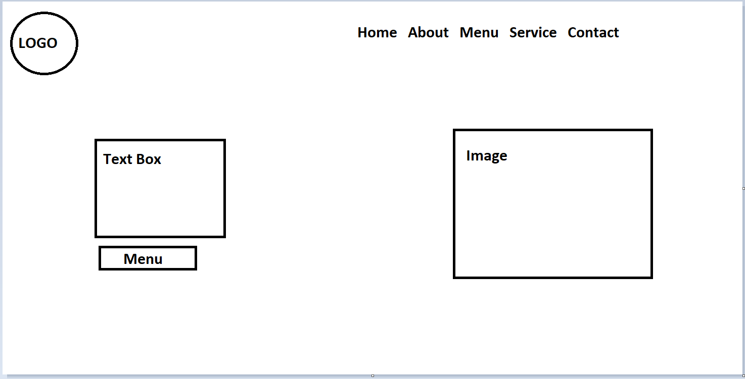
Menu page
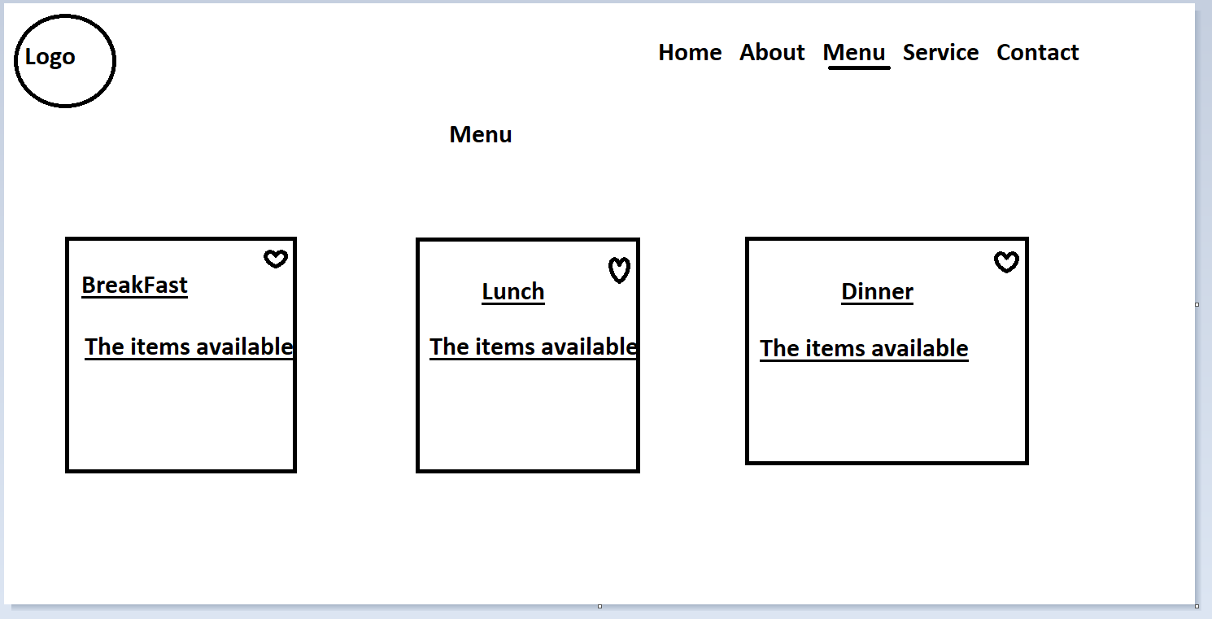

Breakfast Page
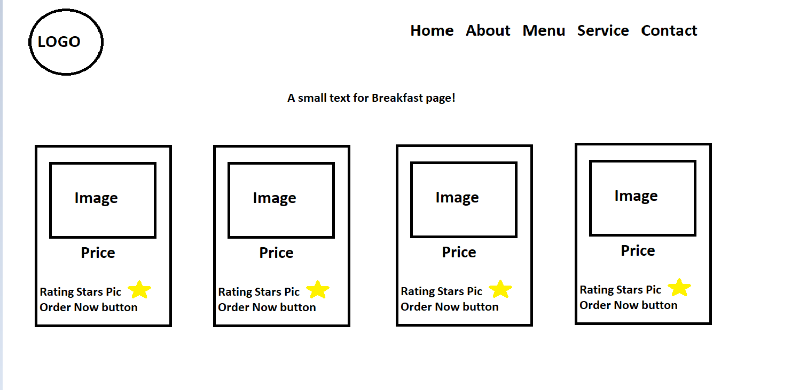

This is how I want my Foodstore website to look. I want it to be simple, sleek and modern. I aim to make it easy to use for everyone visiting my website. I took inspiration from many restaurant websites and food stores hence it gave me a lot of small ideas and tips that I can include. This website can also make users’ decisions more leisurely.
Pros:
- Very simple design
- Modern look
- Good colour combination
- Layout itself
- Easy to get around
- Pictures are high quality while following Rules and Laws
Cons:
- Not much I can say yet since I haven’t started making the website itself

2. Skapa en projektplan!
Beskrivning av projektet:
- Vad är det för typ av hemsida du ska skapa?
When people visit my website, I want them to feel comfortable and familiar. The design will be simple and elegant, not too fancy. The main focus will be on showing delicious food in a visually appealing way, without unnecessary clutter. The menu will be presented nicely, so it looks attractive and shows all the tasty options.

The colours used on the website will be chosen to make the food images stand out and be the main focus. The background will be dark and simple, without any distracting images or graphics.

I will use basic icons like "add to cart," "checkout," and "order/home delivery" to make it easy for people to navigate and use the website. The text will be simple and easy to read, without any fancy decorations. I like the Nunito font because it looks clean and elegant, so I'll explore similar options for my website.

I will bring all my knowledge and experience from previous projects to make sure the website is of the highest quality. I want this website to be even better than anything I've done before and be a great example of excellence.

- Vad är syftet med hemsidan? Vad ska den användas till?
I believe that a food-focused website can have a positive impact. My goal is to design a platform that people can trust and rely on. I want to create an online space where you can easily find and satisfy your food cravings. The website will be easy to use, so you can explore a wide variety of delicious food options without any trouble. It doesn't matter where you are; you'll be able to get access to different kinds of tasty meals right from your own home. Buying food will be easy and convenient, with a smooth and secure process for making payments. The website will also provide helpful information about different restaurants and their menus, so you can make informed choices based on what you like. In short, my vision is to make ordering food a great experience by combining the art of cooking with the convenience of technology. I want to create a digital platform that makes food ordering enjoyable and meets the needs of people who appreciate good food.

Målgrupp:
- Vad har din målgrupp för förväntningar när de besöker din sida? (Tänk vanliga konventioner, dvs. Hur ”brukar det se ut” på liknande sidor, var placerar man exempelvis logga, meny, text, bilder etc.)
To start, I created three different pages for my website, each with its unique ideas. I made sure that all the pages had a similar theme, so when you click on different links, it still feels like you're on the same website. I spent a lot of time coming up with a design that would make it easy for users to navigate the website. Instead of using regular buttons, I decided to use text buttons as hyperlinks because they look more professional and less childish.

I also added a small visual cue to show that the text is a hyperlink. When you hover over the text, the cursor changes shape and the text colour slightly changes. It's a small animation that lets you know there's a link to another page.

Choosing the right names for the links was an important process. I had to come up with one name for each page that fit well and described what the page is about. After looking at many other restaurant websites online, I settled on five links, which is a common setup for food websites.

When you click on a link, you're taken to a page dedicated to that topic. For example, if you click on the "MENU" button, you'll see a separate page with a menu that displays three different meal options. This page shows all the food available at the restaurant. If you click on one of the three links on the menu page, like "breakfast," you'll see a menu specifically for breakfast items. Each breakfast item was carefully chosen after doing research, and the prices were determined based on average prices found on reliable platforms like Google.

In summary, my website is carefully designed with three distinct pages that share a common theme. Navigating through the website is easy with text-based hyperlinks and subtle animations to indicate clickable links. Each link takes you to a specific page related to its topic. The result is a seamless and immersive experience where users can find valuable culinary information and enjoy exploring the world of food.

- Vilken är din målgrupp? Vilka ska besöka sidan?
Secondly, I am also targeting 15 → upwards of any age. The reason is that before 15 kids don’t have enough knowledge of what each food is containing or what minerals it has for them. If I have time I would add children's food items as well but the main focus is on actual food. Lastly, I would also want to add a sweets/deserts section for all ages since I think it would create a great match with the food website itself.

Gränssnittet
- Beskriv med ord vad som ska finnas med på sidan samt hur du tänker dig att det ska presenteras visuellt.
- I want it to be sleek and simple. I believe I want it to be simple so most users can easily get around it.
- Food images
- Food Logos
- Food icons
- Text boxes
- Lightbox (Javascript)
Yes, these are the common items that I want to have on my page. If something changes I will also update it here.
- Hur kommer din design, layout och innehåll anpassas efter målgruppen?
- My website is a modern page with a menu bar including the most common links e.g. menu, about etc. Then I also want the images to stand out more so I have a dark background. Lastly, the text should also have his presence.
- The layout is inspired by online templates, videos and images.
- The layout is also the longest part to do since I want my stuff to be balanced and not all over the place.
- The content targeted to my goals is also designed by feedback from my friends on what option might look better.
Lagar och etik
- Vilka lagar och etiska regler kommer du att behöva ta hänsyn till när du skapar och publicerar din hemsida och HUR tar du hänsyn till dessa?
- I will take care of copyright rules for my website since I will be using numerous images from the internet.
- Probably images which I use, I am going to take them off online. So I will probably after selecting the images do research if I could use those images to not get copyrighted.
- After selecting images I finally got permission and got allowed to use all images I used on my webpage.
- Last but not least I will also follow other rules and laws so I am not copying any information from online. Everything will be taken into consideration.

Punktlista
- Gör en punktlista med saker som ska göras. En steg-för-steg-beskrivning av din arbetsprocess.
- Firstly, find inspiration online. Then decide on my project and start writing the plan.
- Secondly, I want to design the website on PhotoShop and Paint.
- Then I would design a website for link pages and the layout on PhotoShop and Paint as well.
- Then I would start coding visual code by writing the code in HTML and CSS.
- Firstly then I follow my wireframe and code homepage on Visual Code.
- Secondly, I then follow my wireframes and code other pages on Visual Code.
- Thirdly, I then code the links and add the link pages behind them on Visual code.
- Second and lastly, I finalised my code and ask my family for some feedback stuff.
- Lastly, I add the final touches to my code to finish my project.

3. Gör en wireframe (Photoshop)
Home page
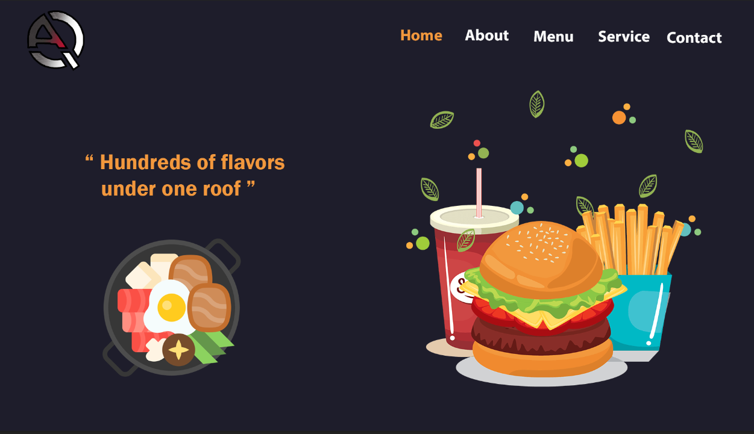
Menu Page
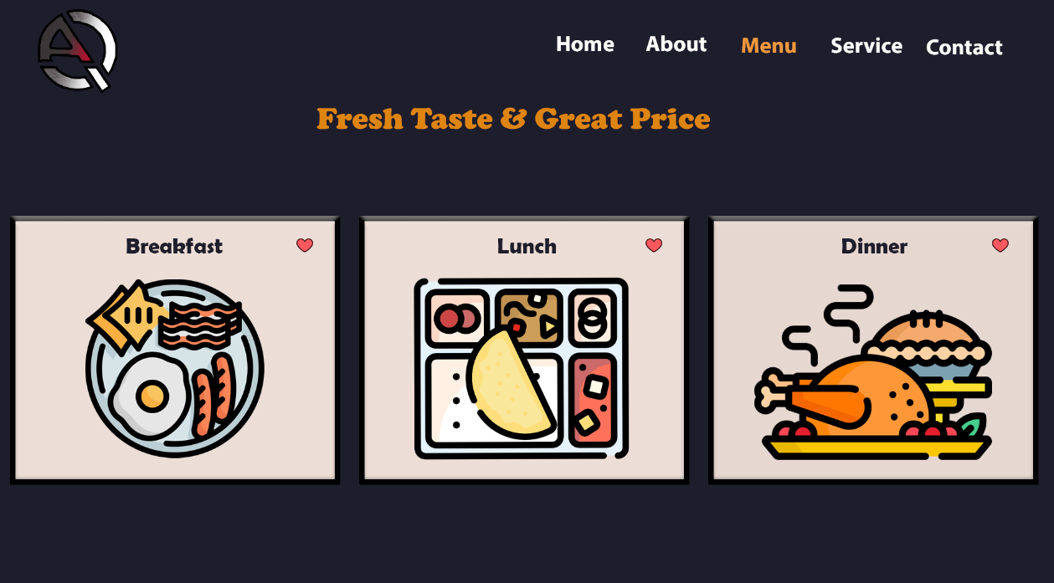
Breakfast Page
